## 3D modelling and Loop workshop at 6IAS

## Practical: Using Noddy to model geophysics from 3D geological scenarios

Mark Lindsay

## Introduction

Noddy is a parametric kinematic 3D modelling package that can be used to visualise structure resulting from a set of defined “events” from a block model. Noddy also has the ability to forward model the potential field response from the block model, allowing us to assess what certain structures would look like in geophysical data.

We will attempt to recreate a representation of the Robinson Range synform (Capricorn Orogen) in Noddy and examine its geometry and resulting geophysical response. Phenomena such as cover, tilting and petrophysics will be explored to determine their effects on the modelling.

|  |  |  |
| --- | --- | --- |
|  |  |  |

Left – dRTP image of the Robinson Range; Centre - Noddy model; Right – magnetic response calculated from Noddy model

## Additional resources

You will find the following PDFs in your 3D practical folder:

* A Noddy reference manual “Noddy_refman” (in case you get stuck)
* The Atlas of Structural Geophysics “Jessell_VirtualExplorer_ASG_print”. This provides many useful examples related to what we are about to do in this practical, and is a useful reference to have at hand when performing interpretation.

## Tasks

**1 – Build the model.**

Open Noddy (obviously).

Your ‘history’ should be visible

First we need to set some project parameters.

*Edit->Geophysics Survey Options…*

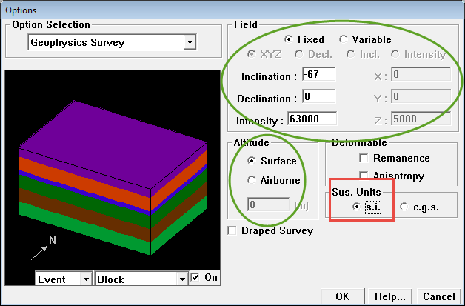

Ensure Sus. Units are ‘s.i.’ (red box). Note the parameters in green. To model our geophysical response as accurately as possible, what should these be? For the time being, we will leave altitude to ‘Surface’.

Click ‘OK’ when these parameters are set appropriately.

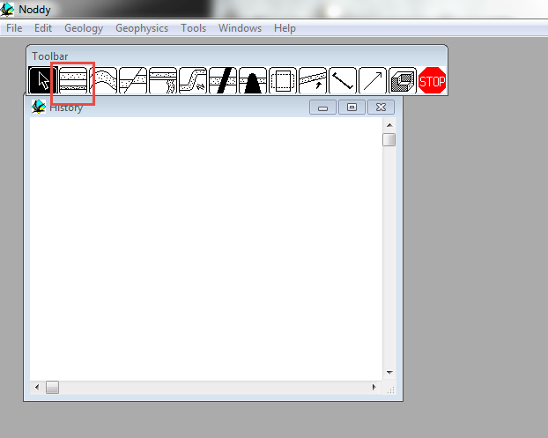

**Add stratigraphy**

Left-click and drag the Stratigraphy icon (red box above) into the History window. The Stratigraphy parameters dialog box will automatically open

Select ‘Upper’ and then click on ‘Edit’

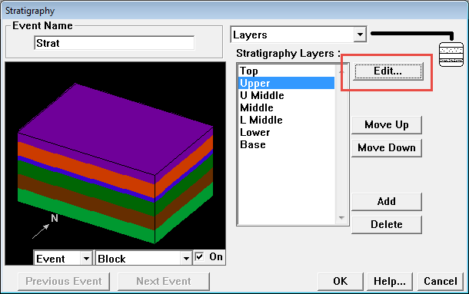

The properties for the Upper unit in our stratigraphy will open. Here we can set a variety of geophysical parameters.

The magnetically susceptible unit in the Robinson Range is suspected to be a BIF, as they tend to be magnetically susceptible:

Set Susceptibility to 0.1 (S.I. units)

BIFs are also typically dense:

Set Density to 3 (gms/cm3)

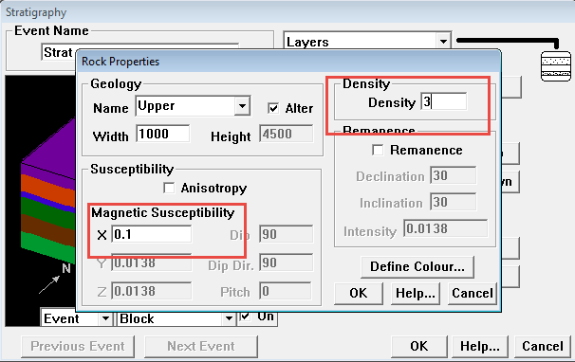

The other units in our stratigraphy also have petrophysical properties. Check each one and ensure that susceptibilities are relatively **low (<0.001)**, as are densities **(<2.5)**. The lower units have quite high densities, why do you think these are assigned as default values?

**Add a folding event**

Click-drag ‘Fold’ (red box) to the History window

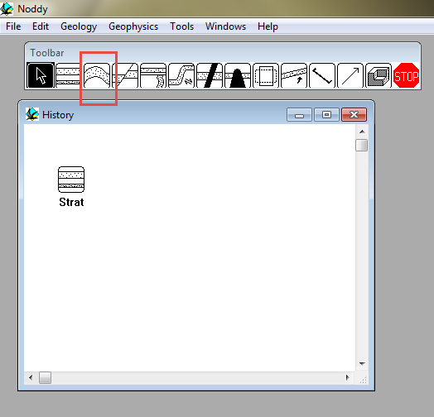

The Fold parameters will automatically open, and you can see you newly folded stratigraphy.

Set the parameters as below

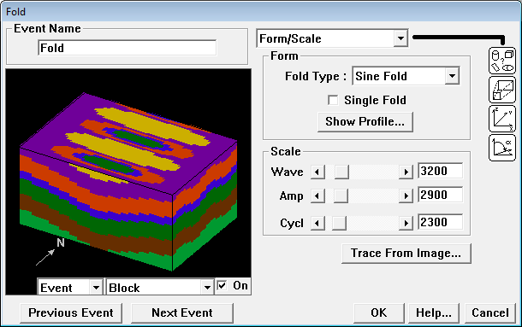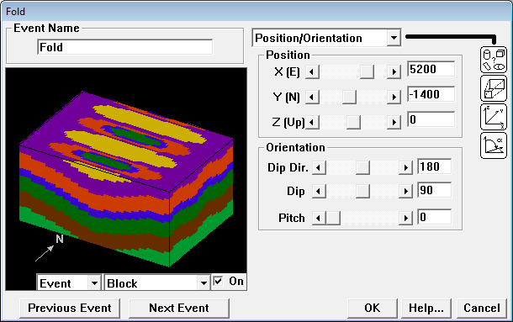

You can see we have now folded our stratigraphy non-cylindrically, and it’s sort of looking like the Robinson Range

Click OK

To look at this in full 3D (where you can spin the model around)

*Geology->Block diagram*

**Add a second folding event**

Use the following parameters:

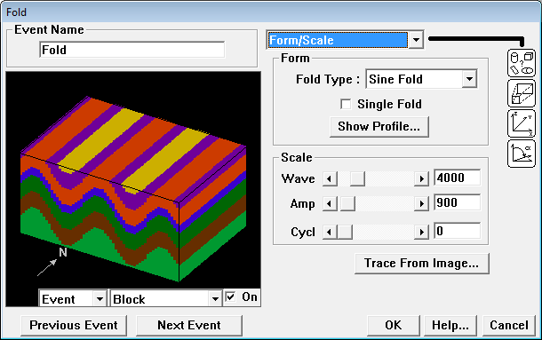

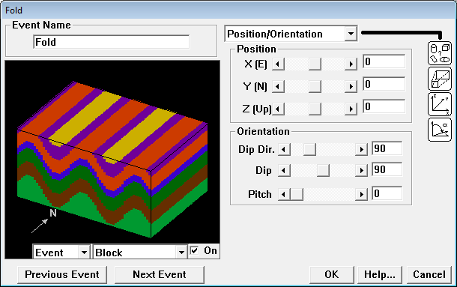

In the drop-down menu at the bottom-left, choose ‘History’ to see the results of refolding the stratigraphy.

**Model the magnetic and gravity response**

Noddy will produce a map view of the geophysical response, as if a magnetic and gravity survey had been conducted over your new creation.

*Geophysics->Calculate Anomalies->Anomalies…*

A window will open prompting you to save the images. Choose a sensible name e.g. ‘Refold’ and a sensible location e.g. your practical folder. You will be creating few of these images, so a good naming convention will save frustration.

Two files are produced: {name}.grv and {name}.mag, each representing the physical field indicated by the file extension.

|  |  |
| --- | --- |
|  |  |
| Magnetics | Gravity |

To change the colour scheme, right-click the image and select “Psuedo-colour”

When you have done this to the magnetic response, look at the asymmetry in the response.

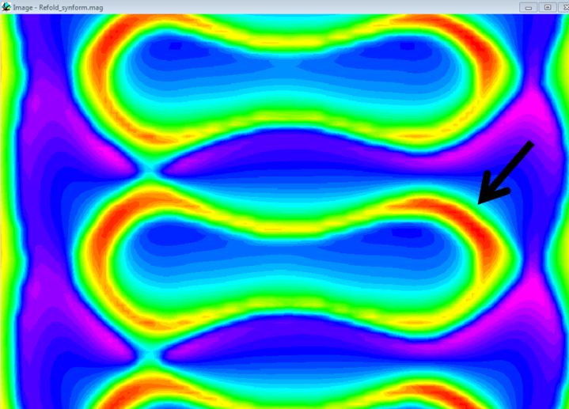

For example, the ‘highs’ (the red parts) are more prevalent on the northern edge of the magnetic horizon.

What do you think is causing this effect? *Hint:* Compare with the gravity image. Do you see the same effect? Also, look at the geophysical survey parameters we set earlier. How can we ‘correct’ this?

*You should correct this (or at least understand why it’s there) before moving to the next steps*

**Using the ‘profile tool’**

Click and drag a line on the magnetic image to sample a profile from the geophysical response of your model. See below for an example.

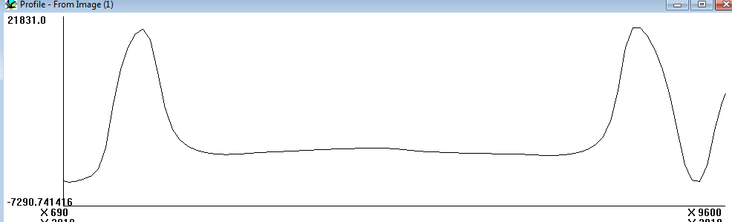

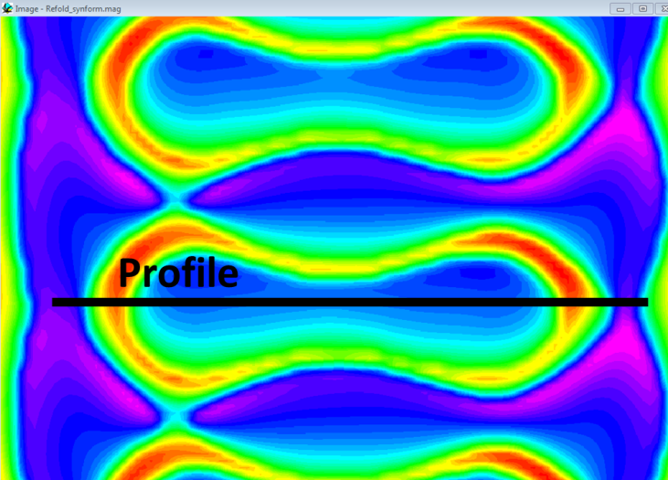

The asymmetry mentioned earlier can be seen in a N-S profile

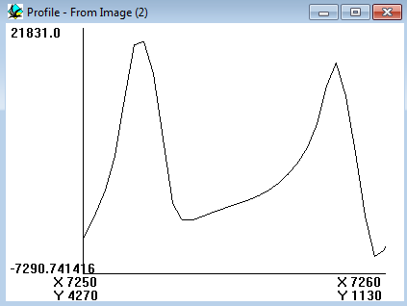

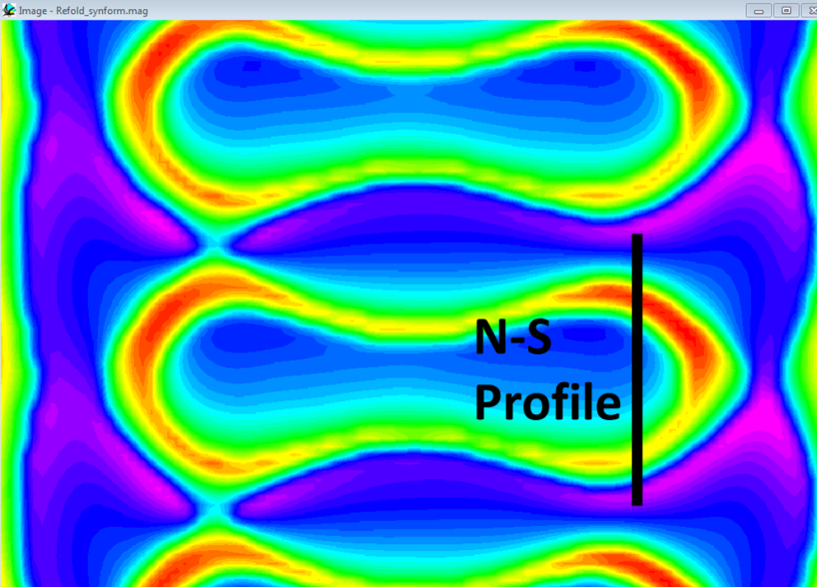

Creating profiles in this way can be a useful way of comparing the signals seen in ‘real’ data collected from your field area, and those measured from your synthetic examples generated in Noddy. If the signals are comparable in both wavelength and amplitude, you can use this as one form of support for your interpretation.

Compare with the signal from the real geophysical data.

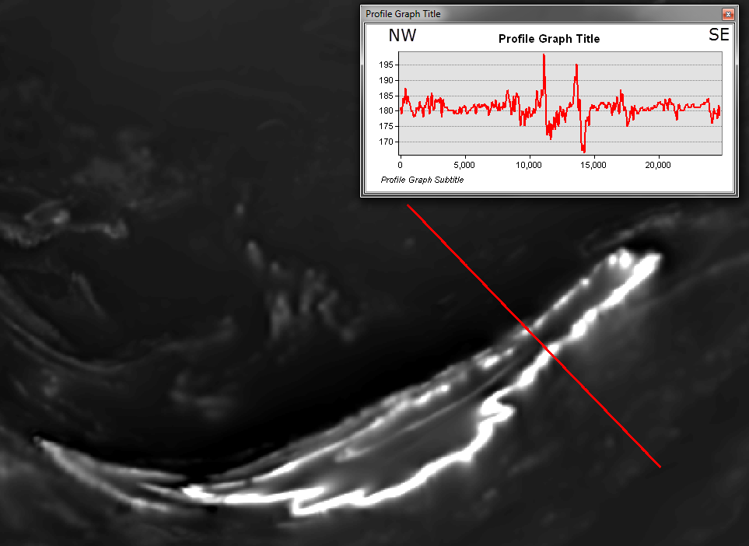

This magnetic data has been reduced-to-the-pole, but an asymmetry still exists. There are several possible reasons for this, both geological (think geometry), and geophysical (think processing).

**The effect of cover on your geophysical signal**

Let’s add an unconformity to the model. Click and drag the Unconformity icon to the History window

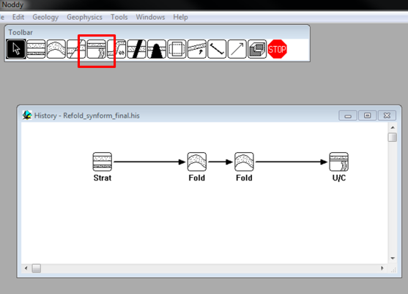

Set the parameters as follows:

First, go to the “Layers” sub-menu and remove all layers **except ‘Top’**.

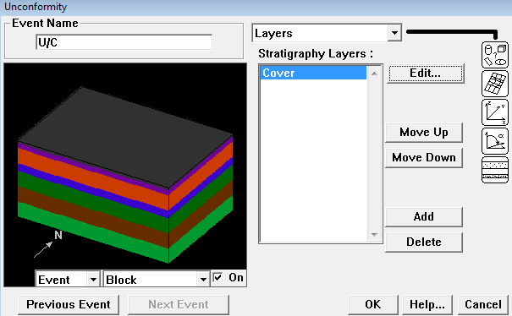

Then click on ‘Top’ and rename it to ‘Cover’. Also set the Density to 2.2 (low density appropriate recent cover and set Susceptibility to 0.0001 – essentially non-magnetic)

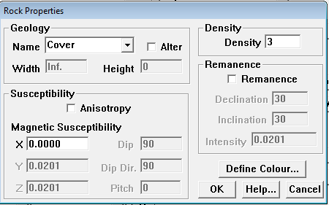

Set the other parameters as follows:

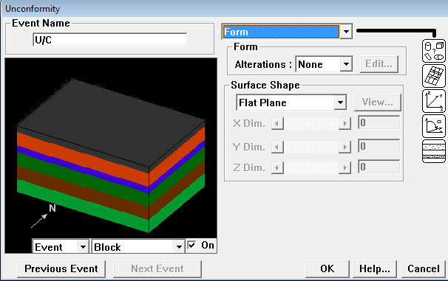

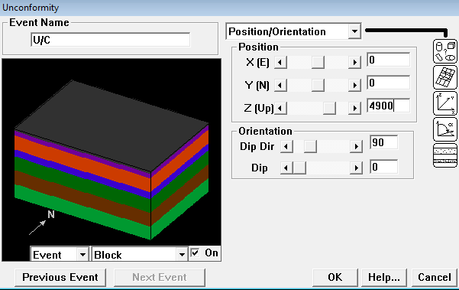

Note we set the **thickness** of cover with the *Z* *(up) parameter*

**5000** **m** is the height of the Earth’s surface from the base of the model. So if we set it to **4900 m**, then we set the base of the unconformity to be **100 m** *below* the Earth’s surface. Noddy then fills the model to the surface with the ‘Cover’ unit.

**Calculate anomalies with 100 m of cover (call the files {name}_100m_nonmag_lowden_cover. What do you expect to see? What differences between mag and grav anomalies do you see between non-covered and covered models?**

The effect of cover supresses the signal, but also we have ‘eroded’ away 100m of the original model, and we are now imaging a slice 100m deeper.

Don’t forget to check the signal from the profile. Note whether the dynamic range of the signal changes. The minimum and maximum values are shown on the y-axis of the profile plot.

**Start changing the Cover parameters and re-calculate the anomalies**

Try these (to start with):

1. Change the dip (and dip direction) of the unconformity surface (angular disconformity)
2. Different thicknesses
3. Different petrophysical values (magnetic suscecptibilty and/or density).

**Try adding different events (faults, shearing, tilting, plugs etc).**

The model in its current form is somewhat like the real Robinson Range, but it could be a lot better! What events would produce a closer representation?

**Different magnetic parameters**

Assign a remanent signature to the ‘Robinson Range’ unit. Remember, it’s in the Stratigraphy icon. Edit the Upper unit and check the ‘Remanence’ box and set the parameters accordingly.

**Create your own event history**

There are plenty of scenarios that can be modelled using Noddy. Why not try to create one from your field area?

## Relevant Learning Outcomes

* Build synthetic models to support interpretations
* Explore the effect of different geological and petrophysical parameters on the geophysical response
* Use profile analysis to identify subtle geometries in the geophysical response.